Exp 37

AIM: Design NFA using simulator to accept the string that start and end with different

symbols over the input {a,b}.

INPUT:

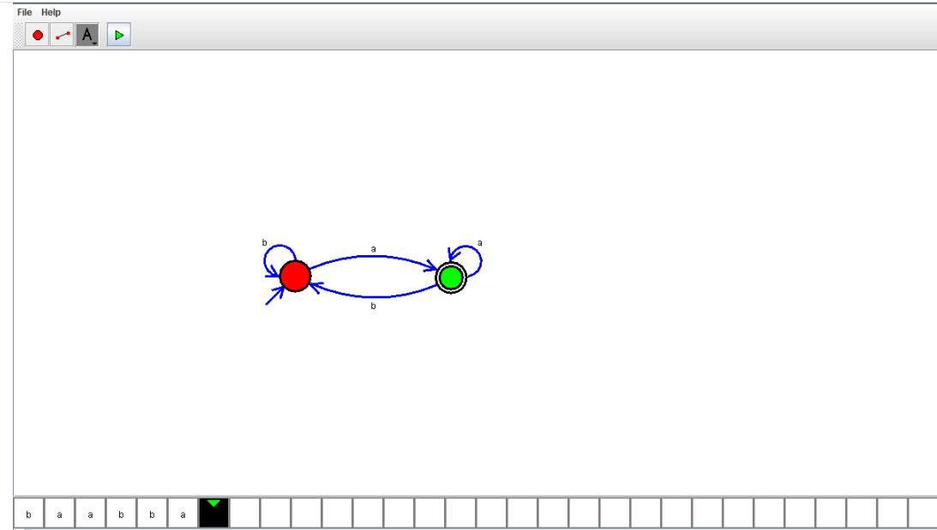

OUTPUT:



RESULT:

NFA using simulator to accept the string that start and end with different

symbols over the input {a,b}. is verified